The document is for explaining the parameter of the tree growth model.

#pragma region Parameters

/**

* **\brief** How many lateral bud will a internode generate. Larger value means more branching.

*/

int m_lateralBudPerNode = 2;

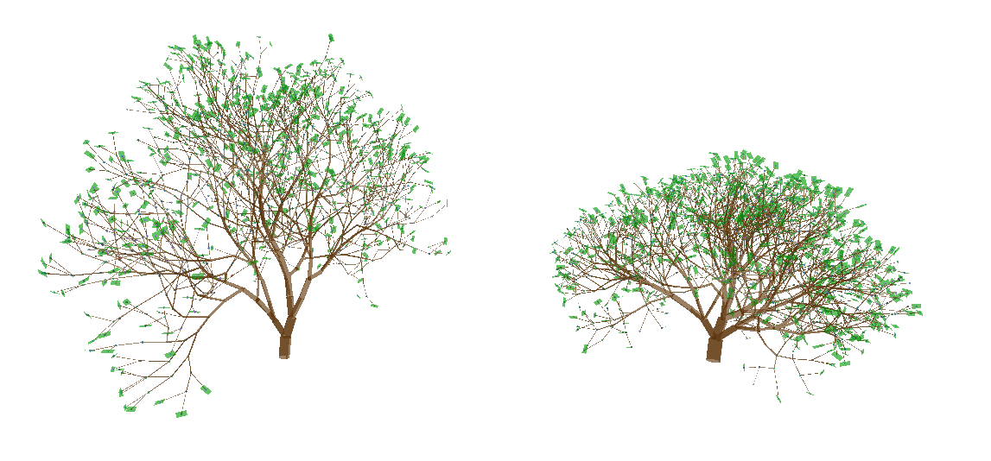

Figure 1: 1 vs 2

#pragma region Geometric

/**

* **\brief** The average of apical angle. Smaller value means straighter branches.

*/

float m_apicalAngleMean = 15.0f;

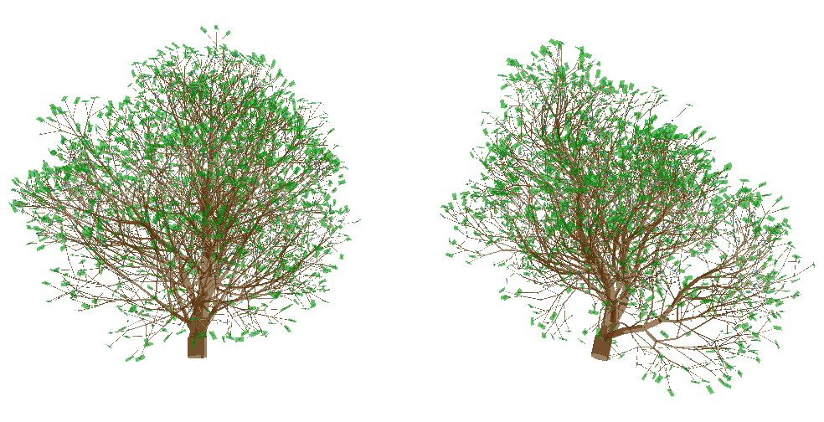

Figure 2: 5 vs 20

/**

* **\brief** The variance of apical angle.

*/

float m_apicalAngleVariance = 1.0f;

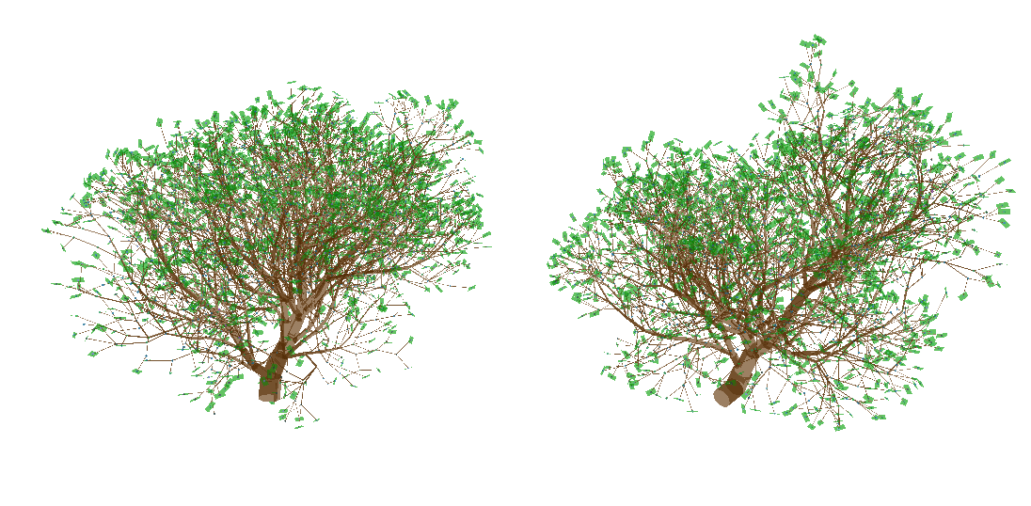

Figure 3: 1 vs 5

/**

* **\brief** The average of branching angle.

*/

float m_branchingAngleMean = 30;

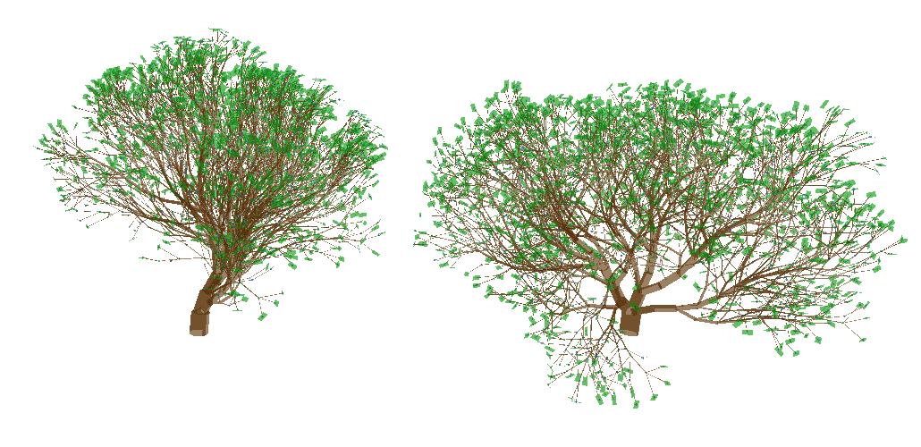

Figure 4: 15 vs 30

/**

* **\brief** The variance of branching angle.

*/

float m_branchingAngleVariance = 2;

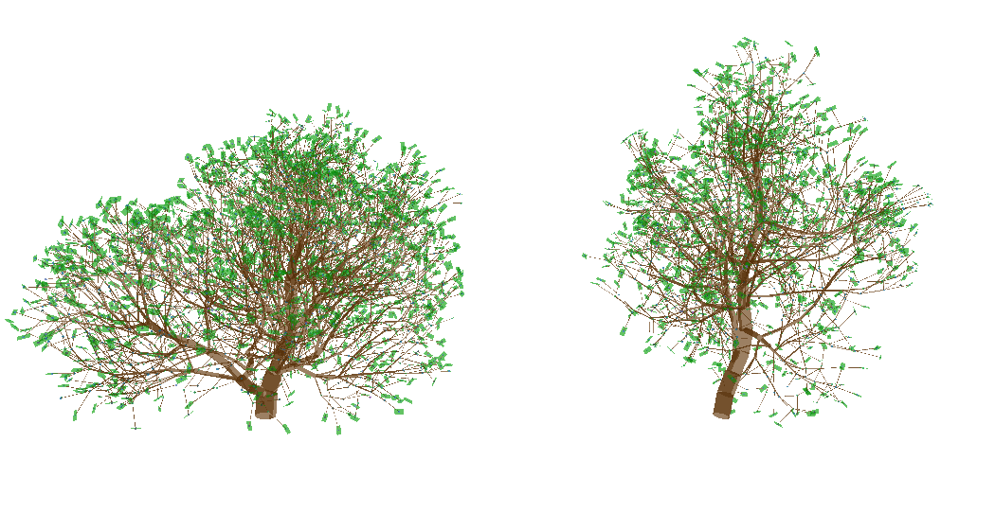

Figure 5: 2 vs 8

/**

* **\brief** The average of roll angle.

*/

float m_rollAngleMean = 60;

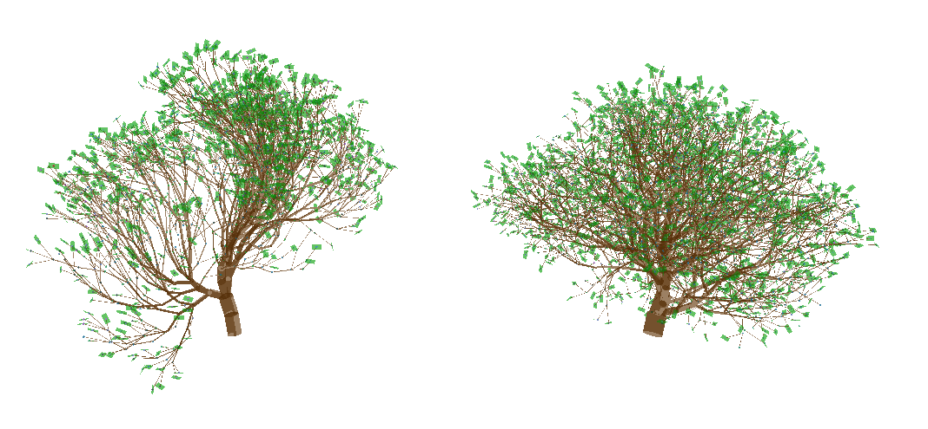

Figure 6: 30 vs 75

/**

* **\brief** The variance of roll angle.

*/

float m_rollAngleVariance = 1;

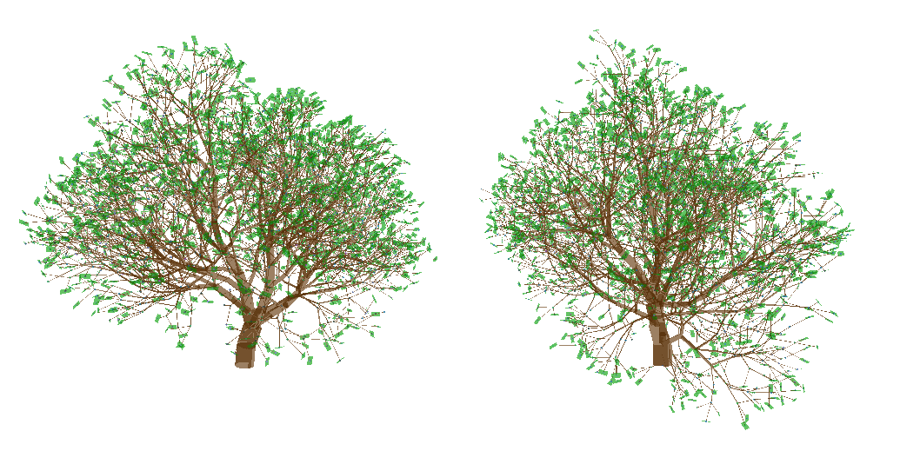

Figure 7: 1 vs 8

/**

* **\brief** The distance between two nearest internodes. Only illumination estimation is related to this.

*/

float m_internodeLengthBase = 1;

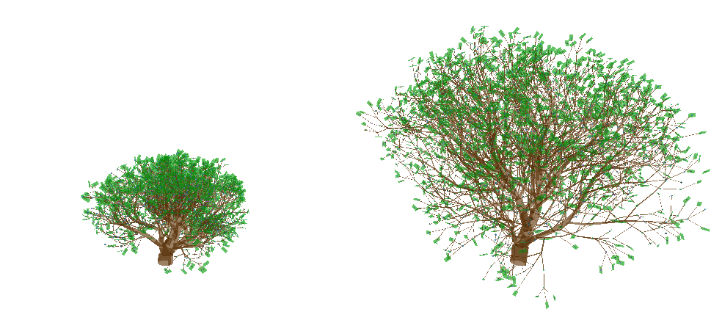

Figure 8: 0.5 vs 1.0

#pragma endregion

#pragma region Bud fate

/**

* **\brief** How much carbon does an apical bud needs to flush. Larger value makes apical bud flush

* sooner.

*/

float m_apicalIlluminationRequirement = 1;

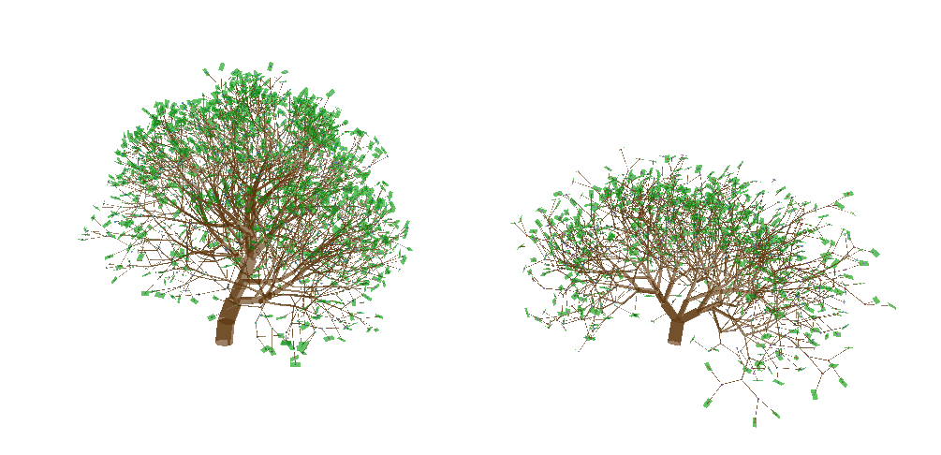

Figure 9: 1 vs 3

/**

* **\brief** How much carbon does a lateral bud needs to flush. Larger value makes lateral bud flush

* sooner.

*/

float m_lateralIlluminationRequirement = 1;

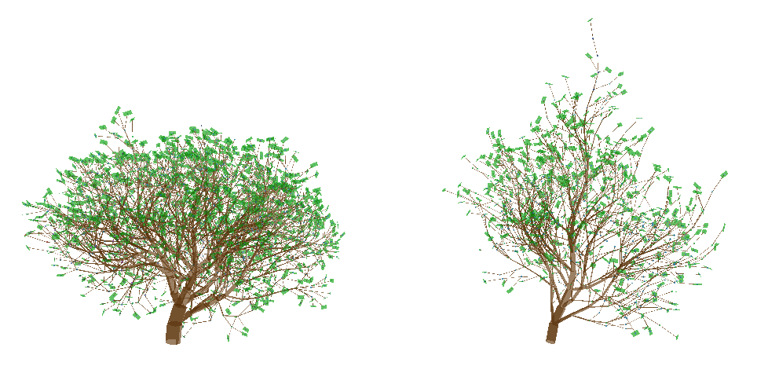

Figure 10: 1 vs 3

/**

* **\brief** How much inhibitor will an internode generate. Inhibitor prohibits parent branches from

* flushing. Here the inhibitor will reduce resource allocated to parent branches.

*/

float m_inhibitorBase = 0.9f;

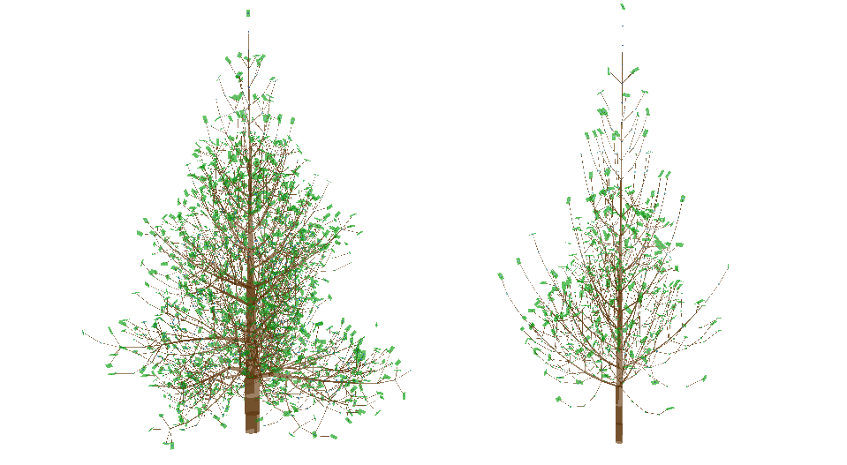

Figure 11: 0.3 vs 1.0

/**

* **\brief** How much inhibitor will be preserved when being transited to parent internodes.

*/

float m_inhibitorDistanceFactor = 0.8f;

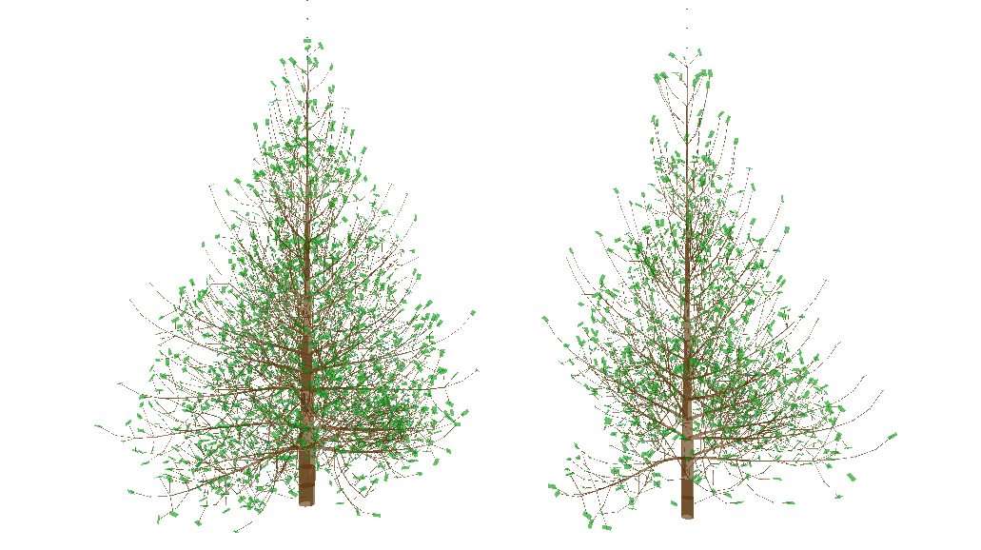

Figure 12: 0.1 vs 0.7

/**

* **\brief** How much resource will an apical bud receive compare with lateral buds from resource allocation.

*/

float m_resourceWeightApical = 1.0f;

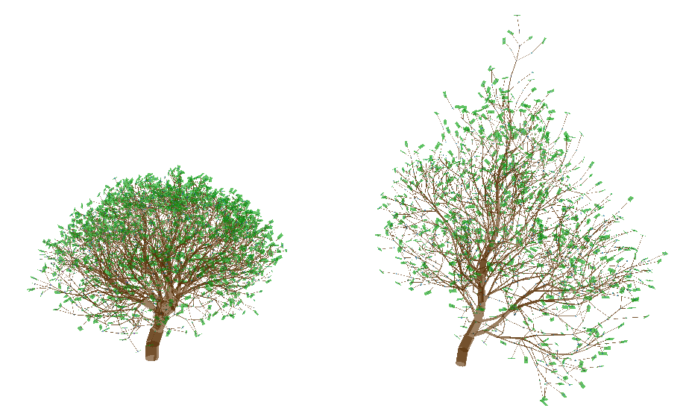

Figure 13: 1.0 vs 1.5

/**

* **\brief** The variance of weight between apical and lateral buds for resource allocation. Larger value

* cause more irregular growth.

*/

float m_resourceWeightVariance = 0.0f;

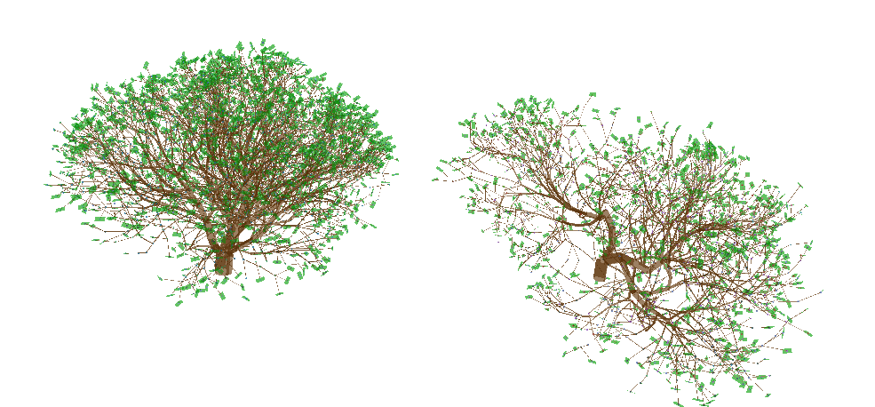

Figure 14: 0.0 vs 0.5

/**

* **\brief** How much will the resource allocation favor to main child. (Child with higher level)

*/

float m_apicalControlLevelFactor = 0.9f;

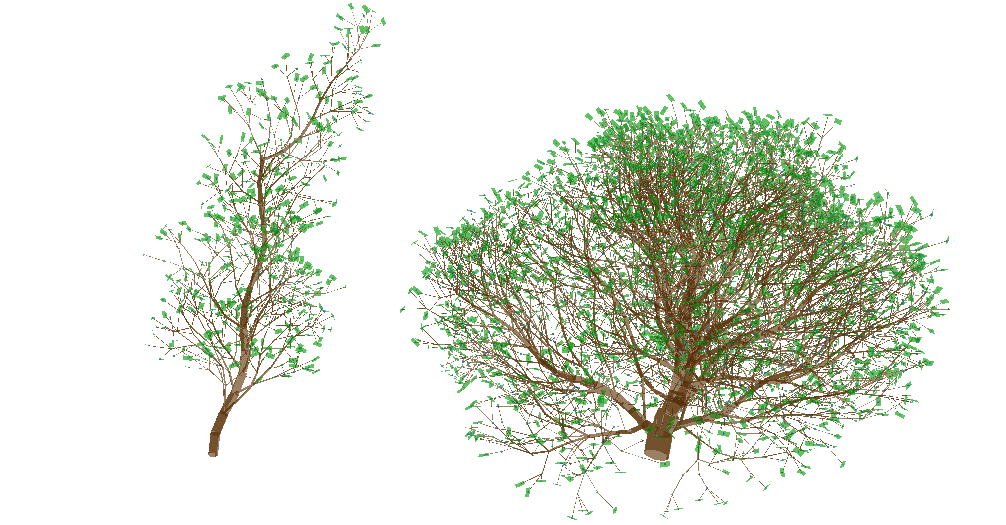

Figure 15: 0.3 vs 0.9

/**

* **\brief** The minimum resource for a plant will grow.

*/

float m_heightResourceHeightDecreaseMin = 0.01f;

/**

* **\brief** How resource decrease as tree grow higher.

*/

float m_heightResourceHeightDecreaseBase = 0.0f;

/**

* **\brief** The speed of how resource decrease as tree grow higher.

*/

float m_heightResourceHeightDecreaseFactor = 1.0f;

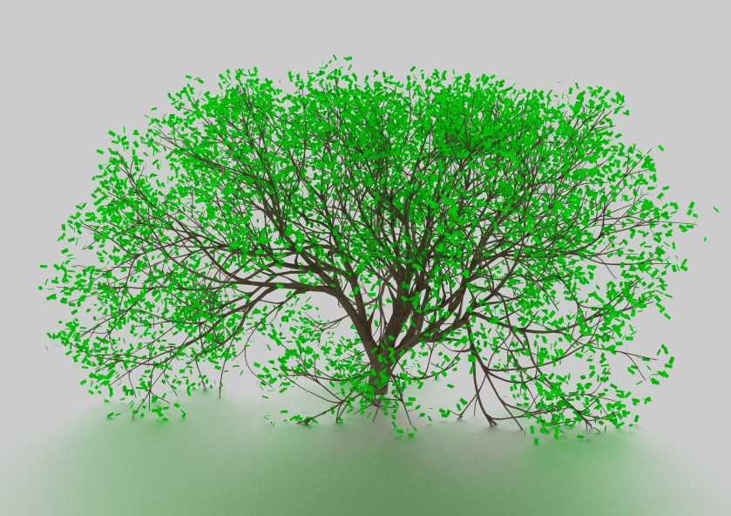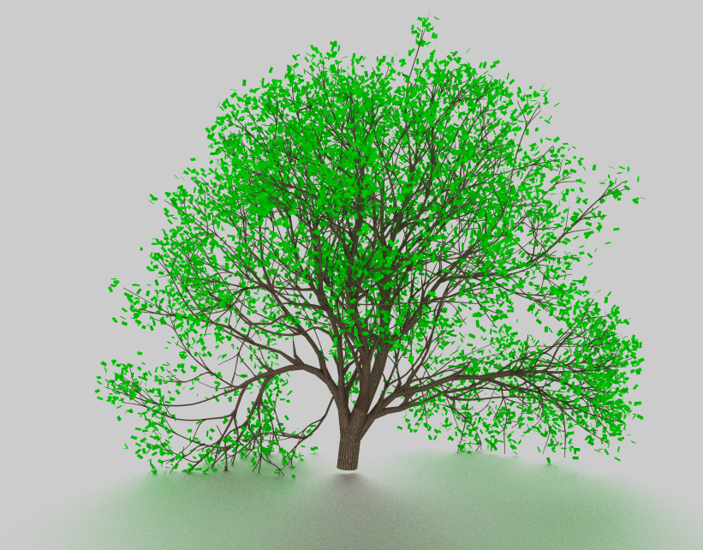

#pragma endregion

#pragma region Environmental

/**

* **\brief** The avoidance angle to prevent self-collision for close branches.

*/

float m_avoidanceAngle = 10.0f;

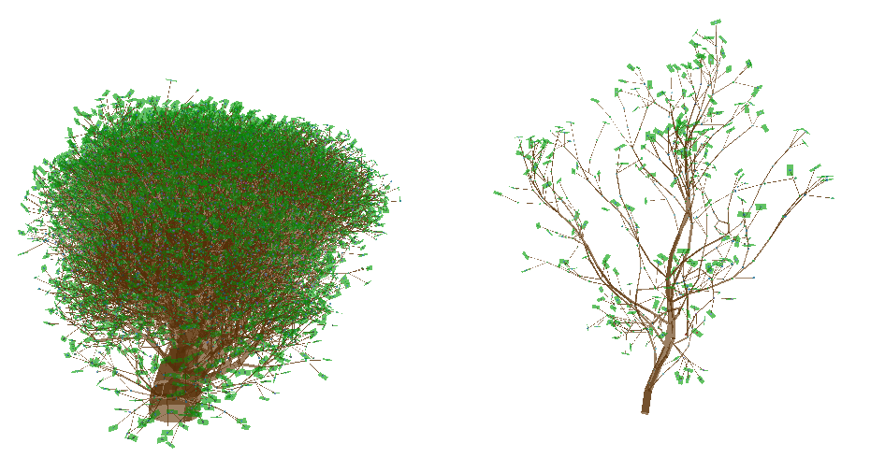

Figure 16: 1 vs 30

/**

* **\brief** How much will an internode rotate towards/against the light direction.

*/

float m_phototropism = 0.0f;

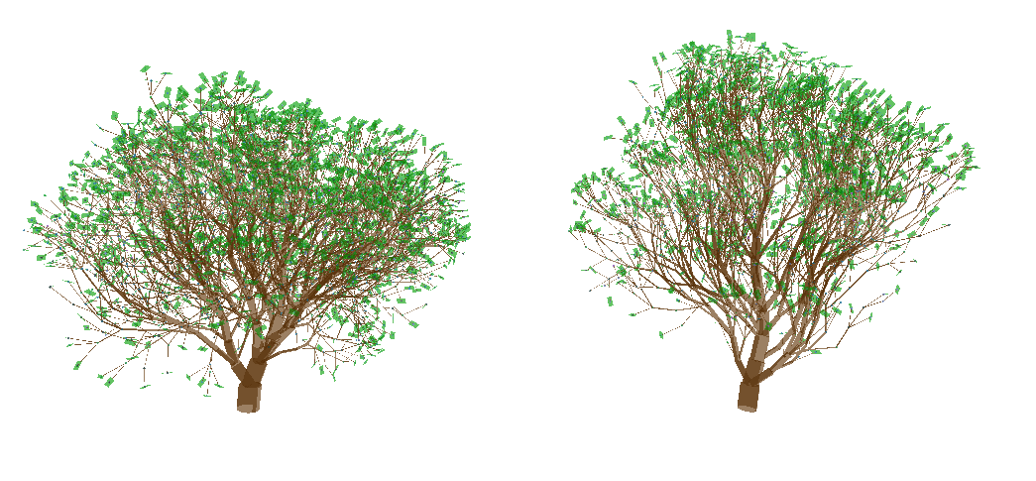

Figure 17: 0.01 vs 0.2

/**

* **\brief** How much will an internode rotate towards/against the direction of gravity.

*/

float m_gravitropism = 0.1f;

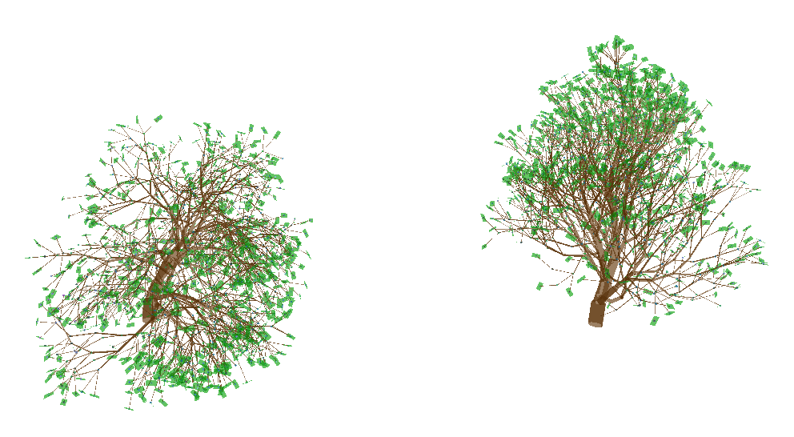

Figure 18: -0.2 vs 0.2

/**

* **\brief** The base probability of an end internode being cut off due to unknown environmental factors.

*/

float m_randomCutOff = -0.02f;

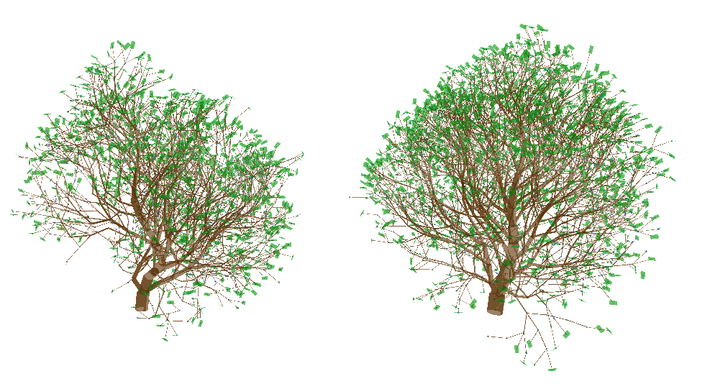

Figure 19: -0.02 vs -0.2

/**

* **\brief** How much the probability of an end internode being cut off due to unknown environmental factors will increase due to internode aging.

*/

float m_randomCutOffAgeFactor = 0.002f;

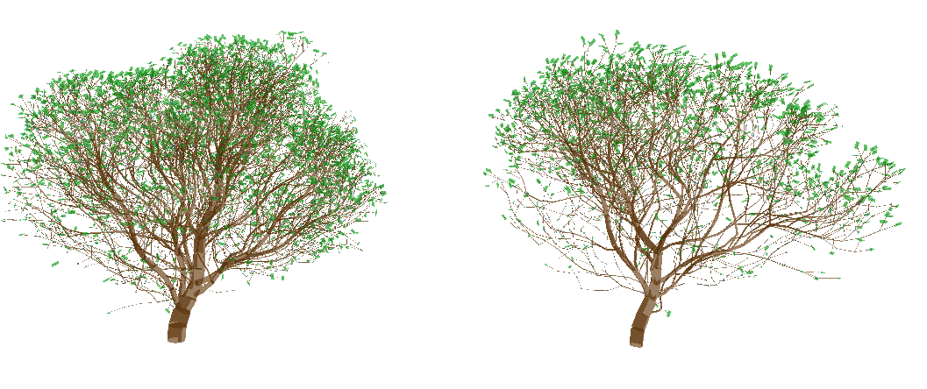

Figure 20: 0.05 vs 0.12

/**

* **\brief** The maximum probability of an end internode being cut off due to unknown environmental factors will increase due to internode aging.

*/

float m_randomCutOffMax = 0.03f;

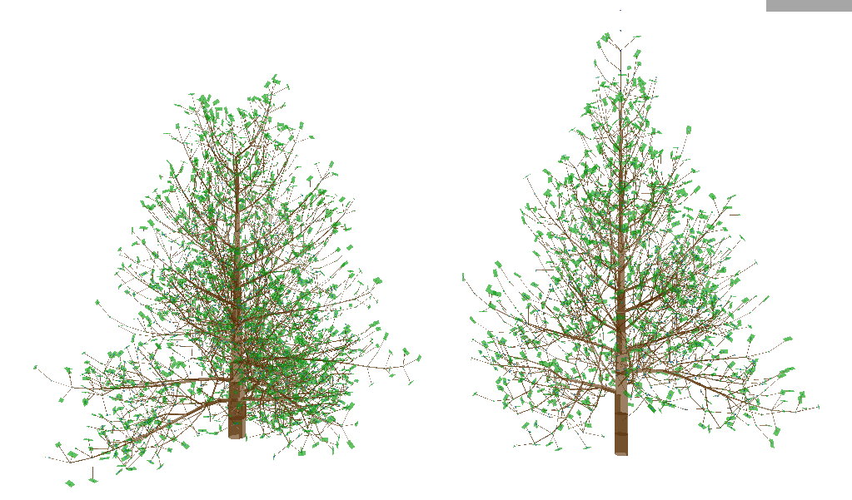

Figure 21: 0.05 vs 0.2

/**

* **\brief** The limit of lateral branches being cut off when too close to the root.

*/

float m_lowBranchCutOff = 0.1f;

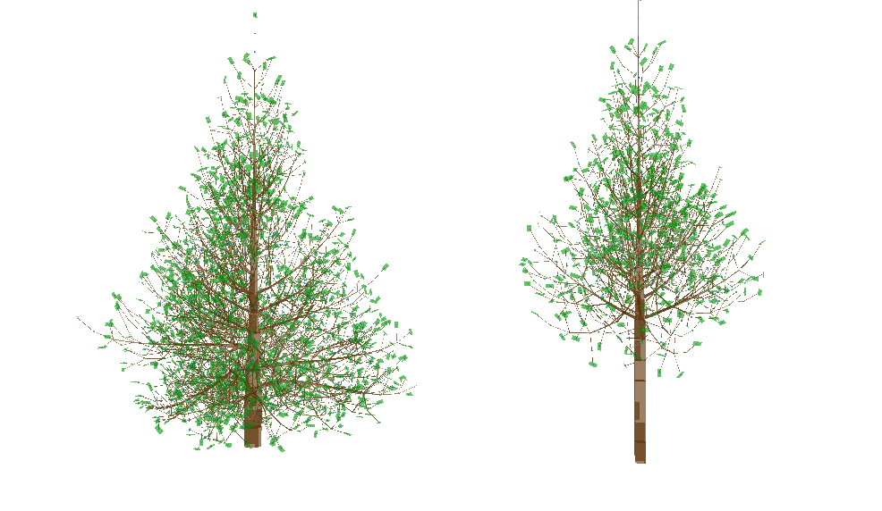

Figure 22: 0.15 vs 0.3

#pragma endregion

/**

* **\brief** The thickness of the end node.

*/

float m_endNodeThickness = 0.01f;

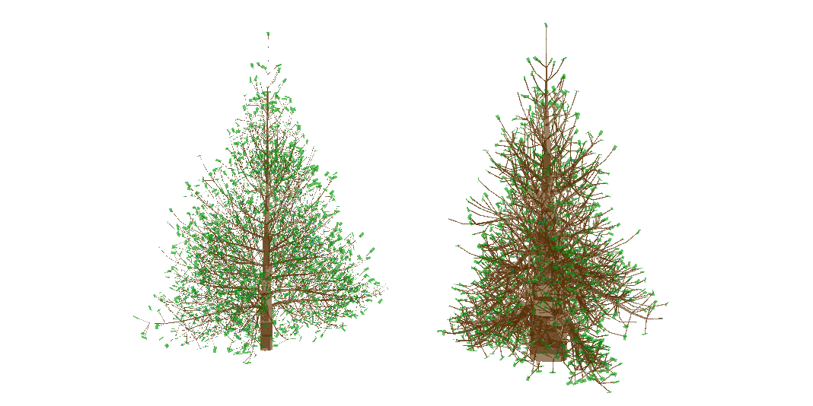

Figure 23: 0.01 vs 0.03

/**

* **\brief** The control factor thickness for thickness calculation.

*/

float m_thicknessControlFactor = 1.0f;

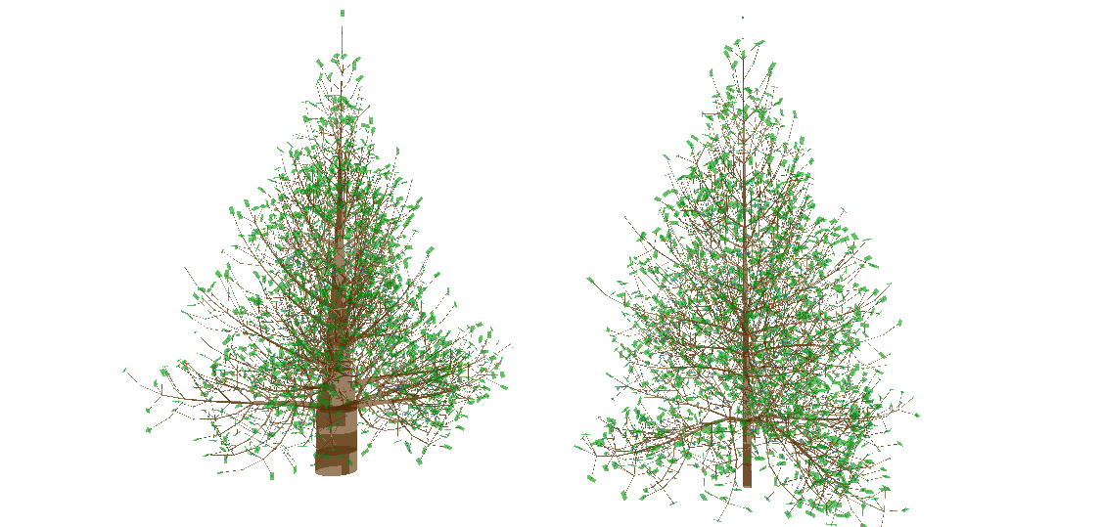

Figure 24: 1.1 vs 0.9

/**

* **\brief** The strength of gravity bending.

*/

float m_gravityBendingFactor = 0.8f;

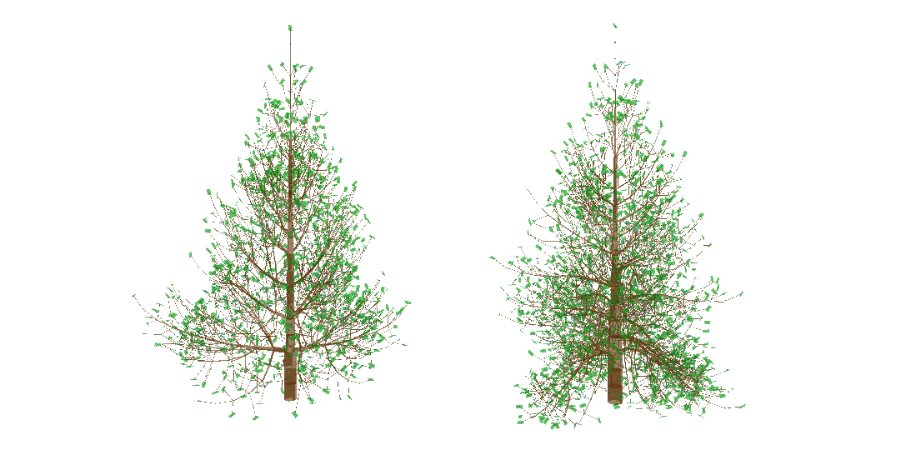

Figure 25: 2.5 vs 8.0

/**

* **\brief** The strength of a branch fight against gravity bending with its thickness.

*/

float m_gravityBendingThicknessFactor = 1.75f;

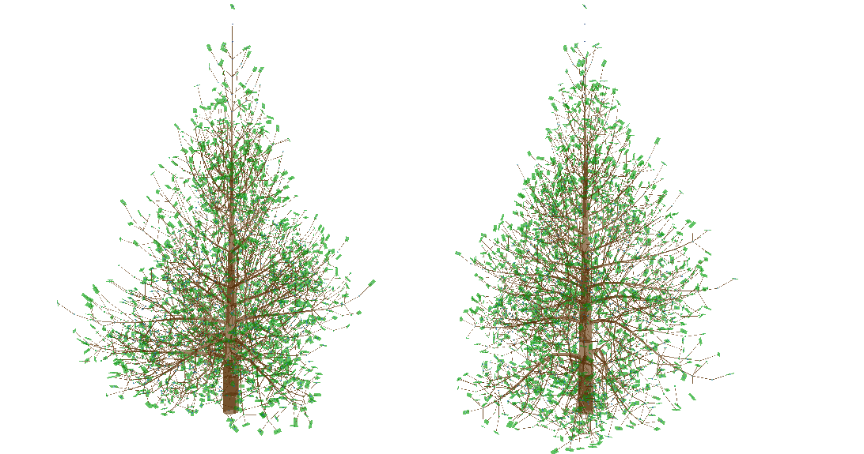

Figure 26: 0.7 vs 1.0

/**

* **\brief** The maximum bending strength of an internode.

*/

float m_gravityBendingMax = 1.0f;

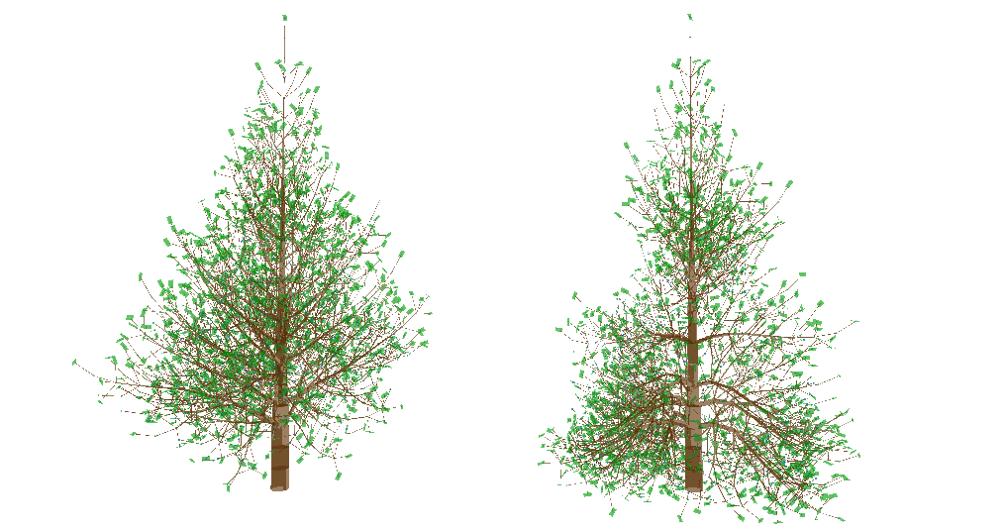

Figure 27: 0.5 vs 2.0

#pragma region Organs

/**

* **\brief** The type of this tree. May affect leaf pattern.

*/

int m_treeType = 0;

#pragma endregion

#pragma endregion